Exp 18
clc; clear; close all;

% Original sequence: x[n] = (0.5)^n u[n]
n = 0:10;
x = (0.5).^n;

% Z-transform and inverse Z-transform
syms z k
Xz = z/(z - 0.5);
xInverse = iztrans(Xz, z, k);

disp('Z-transform X(z) = ');
pretty(Xz);
disp('Inverse Z-transform (symbolic) = ');
pretty(xInverse);

% Numerical reconstruction
xRec = (0.5).^n;
fprintf('Maximum reconstruction error = %.3e\n', ...
max(abs(x - xRec)));
fprintf('Pole = 0.5; Zero = 0; ROC: |z| > 0.5\n');

% Plot original and reconstructed sequences
figure('Name','Experiment 18: Z-transform and Inverse');

subplot(2,2,1);
stem(n, x, 'filled');
grid on;
xlabel('Sample index n');
ylabel('Amplitude');
title('Original sequence');

subplot(2,2,2);
stem(n, xRec, 'r', 'filled');
grid on;
xlabel('Sample index n');
ylabel('Amplitude');
title('Inverse Z-transform reconstruction');
legend('Reconstructed x[n]');
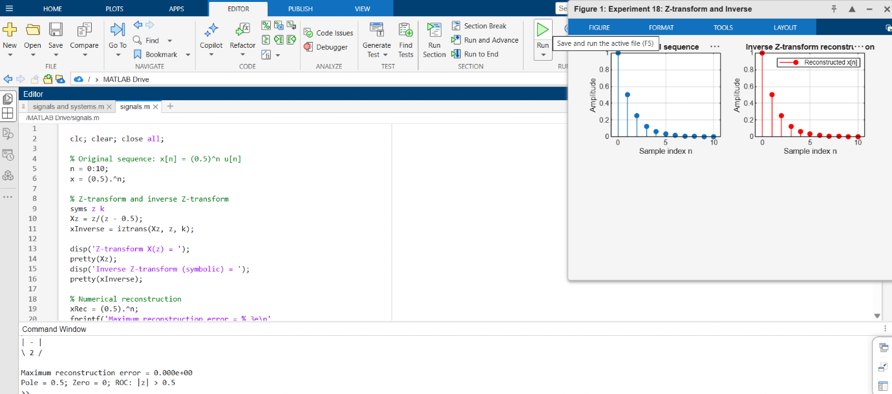
Exp 20
clc; clear; close all;

Fs = 1000;
t = 0:1/Fs:2-1/Fs;

% Chirp signal with 150 Hz transient
x = chirp(t,50,t(end),300,'linear');
idx = (t >= 0.8) & (t <= 1.0);
x(idx) = x(idx) + 0.8*sin(2*pi*150*t(idx));

% STFT / Spectrogram
win = hann(128,'periodic');
noverlap = 112;
nfft = 512;
[S,F,Tstft] = spectrogram(x,win,noverlap,nfft,Fs);

% Plot results
figure('Name','Experiment 20: STFT and Wavelet Analysis');

subplot(3,1,1);
plot(t,x);
grid on;
xlabel('Time (s)');
ylabel('Amplitude');
title('Input: Chirp with 150 Hz transient');

subplot(3,1,2);
imagesc(Tstft,F,20*log10(abs(S)+eps));
axis xy;
xlabel('Time (s)');
ylabel('Frequency (Hz)');
title('STFT Magnitude Spectrogram');
colorbar;
ylim([0 400]);
